**Ms Word Components**

1. **Title bar**
2. **Menu bar -including tabs**
   1. Home
   2. Insert
   3. Page layout
   4. References
   5. Mailings
   6. Review
   7. View
3. **Tab related tool bar / formatting tool bas**
4. **Quick access tool bar/ standard tool bar**
5. **Rulers** 
   1. Horizontal ruler
   2. Vertical ruler
6. **Scroll bar**
   1. Horizontal scroll bar
   2. Vertical scroll bar
7. **Working area**
8. **Status bar** – view buttons, zoom in, zoom out.

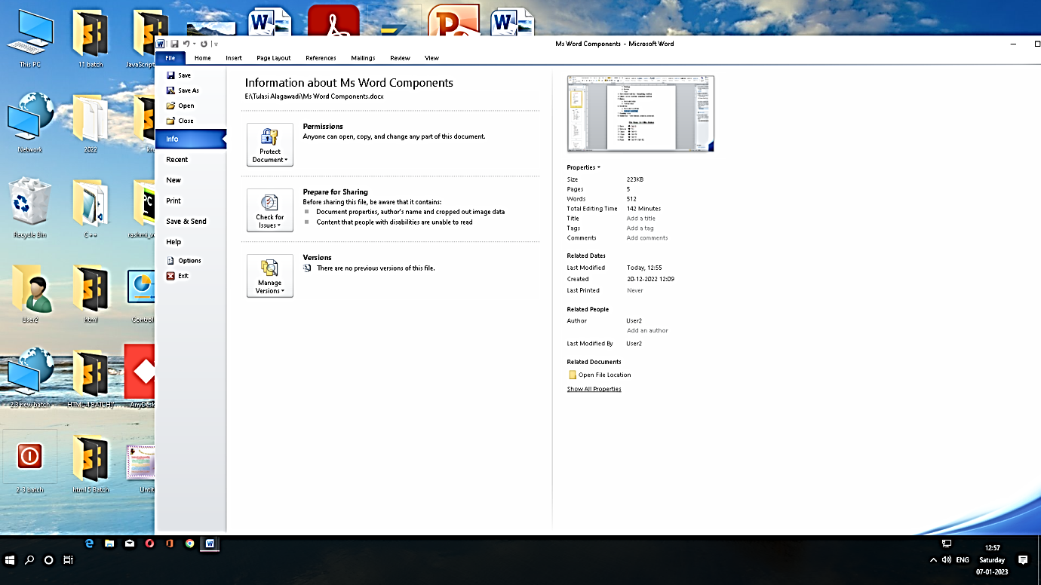

**File Menu Or Office Button**

1. Save 🡺 Ctrl+S
2. Save as 🡺 F12
3. Open 🡺 Ctrl+O
4. Close 🡺 Ctrl+W
5. New 🡺 Ctrl+N
6. Print 🡺 Ctrl+P/ Ctrl+F2

**Home Tab**

**5 groups**

1. **Clip board Group**
   1. Cut 🡺 Ctrl+X
   2. Copy 🡺 Ctrl+C
   3. Paste 🡺 Ctrl+V
   4. Format Painter 🡺 Ctrl + Shift + C

Ctrl + Shift + V

1. **Font Group**
   1. Bold 🡺 Ctrl + B
   2. Italic 🡺 Ctrl + I
   3. Underline 🡺 Ctrl+U
   4. Superscript 🡺 Ctrl+Shift+ =
   5. Sub script 🡺 Ctrl+ =
   6. Increase font 🡺 Ctrl+shift+ > or Ctrl+]
   7. Decrease font 🡺 Ctrl+shift+ < or Ctrl+[
   8. Font 🡺 Ctrl+Shift+F
   9. Font size 🡺 Ctrl+Shift+P
   10. Change case 🡺 Shift + F3
   11. Font dialog box🡺 Ctrl+D
   12. Undo 🡺 Ctrl +Z
   13. Redo 🡺 Ctrl +Y/ F4
2. **Paragraph**
   1. Alignment 4 types
      1. Left 🡺 Ctrl +L
      2. Canter 🡺 Ctrl+E
      3. Right 🡺 Ctrl+R
      4. Justify 🡺 Ctrl+J
   2. Line spacing
      1. Single line 🡺 Ctrl+1
      2. Double line 🡺 Ctrl+2
      3. 1.5 line Space 🡺 ctrl+5
      4. Add or Remove 🡺Ctrl+0
   3. Bullets, Numbering, Multilevel list.
   4. Indent
      1. Decrease indent 🡺 Ctrl+Shift+M
      2. Increase indent 🡺 Ctrl+M
      3. Hanging indent 🡺 Ctrl+ T
      4. First line indent 🡺 Tab key
   5. Sort
      1. Ascending Order 🡺 A-Z/ 1-10
      2. Descending Order🡺 Z-A / 10-1
   6. Shading, Border.
3. **Styles**
4. **Editing** 
   1. Find 🡺Ctrl + F

F5

* 1. Replace 🡺 Ctrl+H
  2. Go to 🡺Ctrl+G
  3. Select All 🡺 Ctrl +A
  4. F1🡺 Help
  5. Ribbon show **OR** hide🡺 Ctrl+F1



**ARROW KEYS**

1. **Left arrow** 🡺 Move the cursor one character Left.
2. **Right arrow** 🡺 Move the cursor one character Right.
3. **Up arrow** 🡺 Move the cursor one line Up.
4. **Down arrow** 🡺 Move the cursor one line Down.

**CTRL + ARROW KEYS**

1. **Ctrl+Left Arrow** 🡺Move the cursor one word Left.
2. **Ctrl+Right Arrow** 🡺Move the cursor one word Right.
3. **Ctrl+Up Arrow** 🡺Move the cursor one paragraph Up.
4. **Ctrl+Down Arrow** 🡺Move the cursor one paragraph Down.
5. **Ctrl+Home Key 🡺** Move the cursor to Beginning of the Document.
6. **Ctrl+End Key 🡺** Move the cursor to End of the Document.
7. **Home key**  🡺Move the cursor beginning of the line.
8. **End key** 🡺Move the cursor end of the line.
9. **Ctrl+ Page up 🡺**Move the cursor one page up.
10. **Ctrl+ page down 🡺**Move the cursor one page down.
11. **Page up key 🡺** Move the cursor one screen up.
12. **Page down key 🡺** Move the cursor one screen down.